IMPLEMENT A MAPREDUCE PROGRAM TO PROCESS A WEATHER DATASET

AIM:

To implement a MapReduce python program to process a weather dataset in Hadoop.

PROCEDURE:

- Open command prompt as administrator and start the Hadoop by using the command:

start-all.cmd

2. Create a new directory in the Hadoop file systems using the command:

hadoop fs -mkdir /weather

3. Upload the input text file into the weather directory using the command:

hadoop fs -put

C:/Users/mercy/OneDrive/Documents/DataAnalytics/WeatherPrediction/sa mple_weather.txt /weather

- Create the mapper and reducer files.

- To execute the files with Hadoop streaming run the following command:

hadoop jar C:/hadoop-3.3.6/share/hadoop/tools/lib/hadoop-streaming-

3.3.6.jar ^ -file

C:/Users/mercy/Documents/DataAnalytics/WeatherPrediction/mapper.py

- -file C:/Users/mercy/Documents/DataAnalytics/WeatherPrediciton/reducer.py

- -input /weather/sample_weather.txt ^ -output /weather/output ^ -mapper "python mapper.py" ^ -reducer "python reducer.py"

MAPPER.PY:

#!C:/ProgramData/chocolatey/bin/python3.exe

import sys

def map1():

for line in sys.stdin:

tokens = line.strip().split()

if len(tokens) < 13:

continue

station = tokens[0]

if "STN" in station:

continue

date_hour = tokens[2]

temp = tokens[3]

dew = tokens[4]

wind = tokens[12]

if temp == "9999.9" or dew == "9999.9" or wind == "999.9":

continue

hour = int(date_hour.split("_")[-1])

date = date_hour[:date_hour.rfind("_")-2]

if 4 < hour <= 10:

section = "section1"

elif 10 < hour <= 16:

section = "section2"

elif 16 < hour <= 22:

section = "section3"

else:

section = "section4"

key_out = f"{station}_{date}_{section}" value_out = f"{temp} {dew} {wind}" print(f"{key_out}\t{value_out}") if __name__ == "__main__":

map1()

REDUCER.PY:

#!C:/ProgramData/chocolatey/bin/python3.exe

import sys

def reduce1():

current_key = None

sum_temp, sum_dew, sum_wind = 0, 0, 0 count = 0

for line in sys.stdin:

key, value = line.strip().split("\t")

temp, dew, wind = map(float, value.split())

if current_key is None:

current_key = key

if key == current_key:

sum_temp += temp

sum_dew += dew

sum_wind += wind

count += 1

else:

avg_temp = sum_temp / count

avg_dew = sum_dew / count

avg_wind = sum_wind / count

print(f"{current_key}\t{avg_temp} {avg_dew} {avg_wind}")

current_key = key

sum_temp, sum_dew, sum_wind = temp, dew, wind count = 1

if current_key is not None:

avg_temp = sum_temp / count

avg_dew = sum_dew / count

avg_wind = sum_wind / count

print(f"{current_key}\t{avg_temp} {avg_dew} {avg_wind}")

if __name__ == "__main__":

reduce1()

OUTPUT:

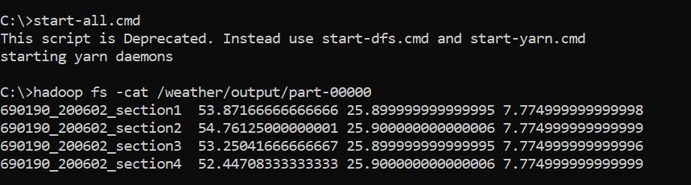

RESULT:

Thus the implementation of the MapReduce python program to process a weather dataset in Hadoop is executed successfully.

